4. Open Chrome DevTools on any website you visit daily (like Instagram or Zomato), go to the Console tab, and type console.log('Hello from the console!') to see the output.
Instagram
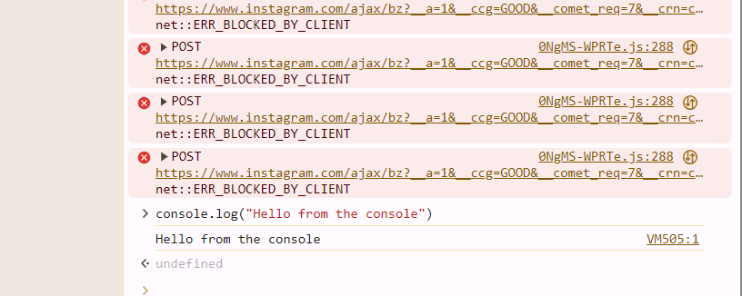

5. Open Chrome DevTools on any website you visit daily (like Instagram or Zomato), go to the Console tab, and type console.log('Hello from the console!') to see the output.
Zomato
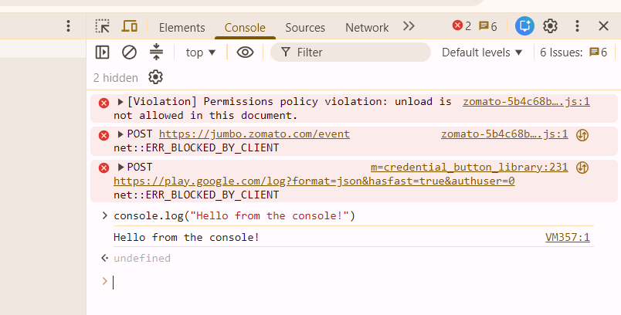

6. Open Chrome DevTools on any website you visit daily (like Zomato or Flipkart), go to the Console tab, and type console.log('JS is running!') to see the output.
Flipkart
